Database Modeling in UML
http://www.sparxsystems.com/resources/uml_datamodel.html
Introduction
When it comes to providing reliable, flexible and efficient object persistence for software systems, today's designers and architects are faced with many choices. From the technological perspective, the choice is usually between pure Object-Oriented, Object-Relational hybrids, pure Relational and custom solutions based on open or proprietary file formats (eg. XML, OLE structured storage). From the vendor aspect Oracle, IBM, Microsoft, POET and others offer similar but often-incompatible solutions.
This article is about only one of those choices, that is the layering of an object-oriented class model on top of a purely relational database. This is not to imply this is the only, best or simplest solution, but pragmatically it is one of the most common, and one that has the potential for the most misuse.
We will begin with a quick tour of the two design domains we are trying to bridge: firstly the object-oriented class model as represented in the UML, and secondly the relational database model.
For each domain we look only at the main features that will affect our task. We will then look at the techniques and issues involved in mapping from the class model to the database model, including object persistence, object behaviour, relationships between objects and object identity. We will conclude with a review of the UML Data Profile (as proposed by Rational Software).
Some familiarity with object-oriented design, UML and relational database modelling is assumed.
The Class Model in the UML is the main artifact produced to represent the logical structure of a software system. It captures the both the data requirements and the behaviour of objects within the model domain. The techniques for discovering and elaborating that model are outside the scope of this article, so we will assume the existence of a well designed class model that requires mapping onto a relational database.
The Class Model
The class is the basic logical entity in the UML. It defines both the data and the behaviour of a structural unit. A class is a template or model from which instances or objects are created at run time. When we develop a logical model such as a structural hierarchy in UML we explicitly deal with classes. When we work with dynamic diagrams, such as sequence diagrams and collaborations, we work with objects or instances of classes and their inter-actions at run-time. The principal of data hiding or encapsulation is based on localization of effect. A class has internal data elements that it is responsible for. Access to these data elements should be through the class's exposed behavior or interface. Adherence to this principal results in more maintainable code.
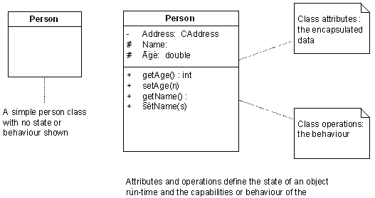
Behaviour
Behaviour is captured in the class model using the operations that are defined for the class. Operations may be externally visible (public), visible to children (protected) or hidden (private). By combining hidden data with a publicly accessible interface and hidden or protected data manipulation, a class designer can create highly maintainable structural units that support rather than hinder change.
Relationships and Identity
Association is a relationship between 2 classes indicating that at least one side of the relationship knows about and somehow uses or manipulates the other side. This relationship may by functional (do something for me) or structural (be something for me). For this article it is the structural relationship that is most interesting: for example an Address class may be associated with a Person class. The mapping of this relationship into the relational data space requires some care.
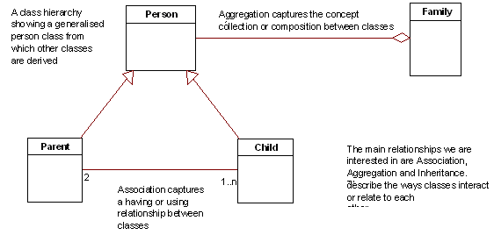
Aggregation is a form of association that implies the collection of one class of objects within another. Composition is a stronger form of aggregation that implies one object is actually composed of others. Like the association relationship, this implies a complex class attribute that requires careful consideration in the process of mapping to the relational domain. While a class represents the template or model from which many object instances may be created, an object at run time requires some means of identifying itself such that associated objects may act upon the correct object instance. In a programming language like C++, object pointers may be passed around and held to allow objects access to a unique object instance. Often though, an object will be destroyed and require that it be re-created as it was during its last active instance. These objects require a storage mechanism to save their internal state and associations into and to retrieve that state as required.
Inheritance provides the class model with a means of factoring out common behaviour into generalised classes that then act as the ancestors of many variations on a common theme. Inheritance is a means of managing both re-use and complexity. As we will see, the relational model has no direct counterpart of inheritance, which creates a dilemma for the data modeller mapping an object model onto a relational framework. Navigation from one object at run time to another is based on absolute references. One object has some form of link (a pointer or unique object ID) with which to locate or re-create the required object.
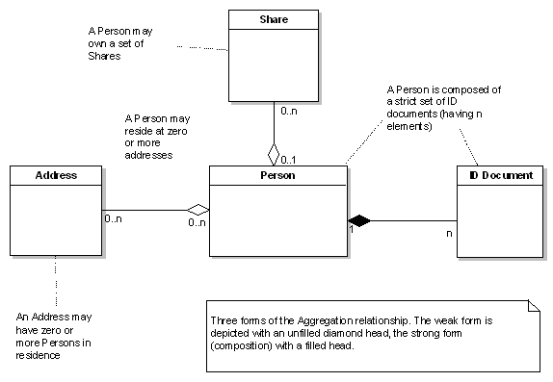
The Relational Model
The relational data model has been around for many years and has a proven track record of providing performance and flexibility. It is essentially set based and has as its fundamental unit the 'table', which is composed of a set of one or more 'columns', each of which contains a data element.
Tables and Columns: a relational table is collection of one or more columns each of which has a unique name within the table construct. Each column is defined to be of a certain basic data type, such as a number, text or binary data. A table definition is a template from which table rows are created, each row being an instance of a possible table instance. The relational model only offers a public data access model. All data is equally exposed and open to any process to update, query or manipulate it. Information hiding is unknown.
Behaviour
The behaviour associated with a table is usually based on the business or logical rules applied to that entity. Constraints may be applied to columns in the form of uniqueness requirements, relational integrity constraints to other tables/rows, allowable values and data types.
Triggers provide some additional behaviour that can be associated with an entity. Typically this is used to enforce data integrity before or after updates, inserts and deletes. Database stored procedures provide a means of extending database functionality through proprietary language extensions used to construct functional units (scripts). These functional procedures do not map directly to entities, nor have a logical relationship to them. Navigation through relational data sets is based on row traversal and table joins. SQL is the primary language used to select rows and locate instances from a table set.
Relationships and Identity
The primary key of a table provides the unique identifying value for a particular row. There are two kinds of primary key that we are interested in: firstly the meaningful key, made up of data columns which have a meaning within the business domain, and second the abstract unique identifier, such as a counter value, which have no business meaning but uniquely identify a row. We will discuss this and the implications of meaningful keys later. A table may contain columns that map to the primary key of another table. This relationship between tables defines a foreign key and implies a structural relationship or association between the two tables.

Summary
From the above overview we can see that the object model is based on discrete entities having both state (attributes/data) and behaviour, with access to the encapsulated data generally through the class public interface only. The relational model exposes all data equally, with limited support for associating behaviour with data elements through triggers, indexes and constraints. You navigate to distinct information in the object model by moving from object to object using unique object identifiers and established object relationships (similar to a network data model). In the relational model you find rows by joining and filtering result sets using SQL using generalised search criteria. Identity in the object model is either a run-time reference or persistent unique ID (termed an OID). In the relational world, primary keys define the uniqueness of a data set in the overall data space.
In the object model we have a rich set of relationships: inheritance, aggregation, association, composition, dependency and others. In the relational model we can really only specify a relationship using foreign keys. Having looked at the two domains of interest and compared some of the important features of each, we will digress briefly to look at the notation proposed to represent relational data models in the UML.
The UML Data Model Profile
The Data Model Profile is a proposed UML extension (and currently under review - Jan 2001) to support the modelling of relational databases in UML. It includes custom extensions for such things as tables, data base schema, table keys, triggers and constraints. While this is not a ratified extension, it still illustrates one possible technique for modelling a relational database in the UML.
Tables & Columns A table in the UML Data Profile is a class with the «Table» stereotype, displayed as above with a table icon in the top right corner. Database columns are modelled as attributes of the «Table» class.
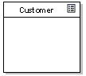
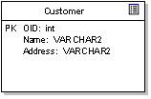

For example, the figure above shows some attributes associated with the Customer table. In the example, an object id has been defined as the primary key, as well as two other columns, Name and Address. Note that the example above defines the column type in terms of the native DBMS data types.
Behaviour So far we have only defines the logical (static) structure of the table; in addition we should describe the behaviour associated with columns, including indexes, keys, triggers, procedures & etc. Behaviour is represented as stereotyped operations.
The figure below shows our table above with a primary key constraint and index, both defined as stereotyped operations:
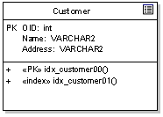
Note that the PK flag on the column 'OID' defines the logical primary key, while the stereotyped operation "«PK» idx_customer00" defines the constraints and behaviour associated with the primary key implementation (that is, the behaviour of the primary key).
Adding to our example, we may now define additional behaviour such as triggers, constraints and stored procedures as in the example below:
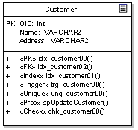

The example illustrates the following possible behavior:
- A primary key constraint (PK);
- A Foreign key constraint (FK);
- An index constraint (Index);
- A trigger (Trigger);
- A uniqueness constraint (Unique);
- A stored procedure (Proc) - not formally part of the data profile, but an example of a possible modelling technique; and a
- Validity check (Check).
Using the notation provided above, it is possible to model complex data structures and behaviour at the DBMS level. In addition to this, the UML provides the notation to express relationships between logical entities.
Relationships The UML data modelling profile defines a relationship as a dependency of any kind between two tables. It is represented as a stereotyped association and includes a set of primary and foreign keys. The data profile goes on to require that a relationship always involves a parent and child, the parent defining a primary key and the child implementing a foreign key based on all or part of the parent primary key. The relationship is termed 'identifying' if the child foreign key includes all the elements of the parent primary key and 'non-identifying' if only some elements of the primary key are included. The relationship may include cardinality constraints and be modelled with the relevant PK - FK pair named as association roles. The illustration below illustrates this kind of relationship modelling using UML.
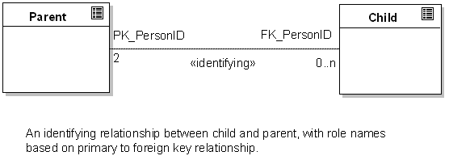

The Physical Model
UML also provides some mechanisms for representing the overall physical structure of the database, its contents and deployed location. To represent a physical database in UML, use a stereotyped component as in the figure below:
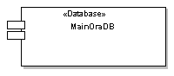
A component represents a discrete and deployable entity within the model. In the physical model, a component may be mapped on to a physical piece of hardware (a 'node' in UML). To represent schema within the database, use the «schema» stereotype on a package. A table may be placed in a «schema» to establish its scope and location within a database.
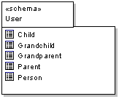
Mapping from the Class Model to the Relational Model
Having described the two domains of interest and the notation to be used, we can now turn our attention as to how to map or translate from one domain to the other. The strategy and sequence presented below is meant to be suggestive rather than proscriptive - adapt the steps and procedures to your personal requirements and environment.
1. Model Classes
Firstly we will assume we are engineering a new relational database schema from a class model we have created. This is obviously the easiest direction as the models remain under our control and we can optimise the relational data model to the class model. In the real world it may be that you need to layer a class model on top of a legacy data model - a more difficult situation and one that presents its own challenges. For the current discussion will focus on the first situation. At a minimum, your class model should capture associations, inheritance and aggregation between elements.

2. Identify persistent objects.
Having built our class model we need to separate it into those elements that require persistence and those that do not. For example, if we have designed our application using the Model-View-Controller design pattern, then only classes in the model section would require persistent state.
3. Assume each persistent class maps to one relational table
A fairly big assumption, but one that works in most cases (leaving the inheritance issue aside for the moment). In the simplest model a class from the logical model maps to a relational table, either in whole or in part. The logical extension of this is that a single object (or instance of a class) maps to a single table row.
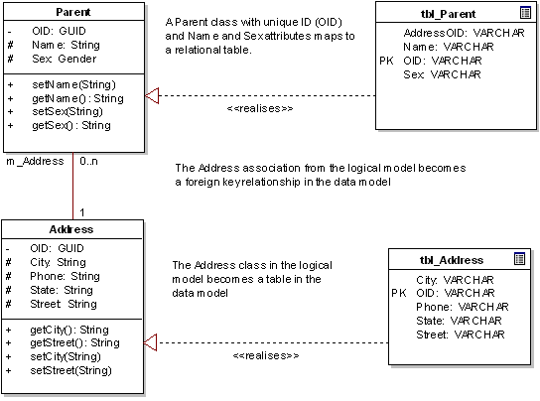
4. Select an inheritance strategy.
Inheritance is perhaps the most problematic relationship and logical construct from the object-oriented model that requires translating into the relational model. The relational space is essentially flat, every entity being complete in its self, while the object model is often quite deep with a well-developed class hierarchy. The deep class model may have many layers of inherited attributes and behaviour, resulting in a final, fully featured object at run-time. There are three basic ways to handle the translation of inheritance to a relational model:

- Each class hierarchy has a single corresponding table that contains all the inherited attributes for all elements - this table is therefore the union of every class in the hierarchy. For example, Person, Parent, Child and Grandchild may all form a single class hierarchy, and elements from each will appear in the same relational table;
- Each class in the hierarchy has a corresponding table of only the attributes accessible by that class (including inherited attributes). For example, if Child is inherited from Person only, then the table will contain elements of Person and Child only;
- Each generation in the class hierarchy has a table containing only that generation's actual attributes. For example, Child will map to a single table with Child attributes only
There are cases to be made for each approach, but I would suggest the simplest, easiest to maintain and less error prone is the third option. The first option provides the best performance at run-time and the second is a compromise between the first and last. The first option flattens the hierarchy and locates all attributes in one table - convenient for updates and retrievals of any class in the hierarchy, but difficult to authenticate and maintain. Business rules associated with a row are hard to implement, as each row may be instantiated as any object in the hierarchy. The dependencies between columns can become quite complicated. In addition, an update to any class in the hierarchy will potentially impact every other class in the hierarchy, as columns are added, deleted or modified from the table.
The second option is a compromise that provides better encapsulation and eliminates empty columns. However, a change to a parent class may need to be replicated in many child tables. Even worse, the parental data in two or more child classes may be redundantly stored in many tables; if a parent's attributes are modified, there is considerable effort in locating dependent children and updating the affected rows.
The third option more accurately reflects the object model, with each class in the hierarchy mapped to its own independent table. Updates to parents or children are localized in the correct space. Maintenance is also relatively easier, as any modification of an entity is restricted to a single relational table also. The down side is the need to re-construct the hierarchy at run-time to accurately re-create a child class's state. A Child object may require a Person member variable to represent their model parentage. As both require loading, two database calls are required to initialize one object. As the hierarchy deepens, with more generations, the number of database calls required to initialize or update a single object increases.
It is important to understand the issues that arise when you map inheritance onto a relational model, so you can decide which solution is right for you.

5. For each class add a unique object identifier
In both the relational and the object world, there is the need to uniquely identify an object or entity. In the object model, non-persistent objects at run-time are typically identified by direct reference or by a pointer to the object. Once an object is created, we can refer to it by its run-time identity. However, if we write out an object to storage, the problem is how to retrieve the exact same instance on demand. The most convenient method is to define an OID (object identifier) that is guaranteed to be unique in the namespace of interest. This may be at the class, package or system level, depending on actual requirements.
An example of a system level OID might be a GUID (globally unique identifier) created with Microsoft's 'guidgen' tool; eg. {A1A68E8E-CD92-420b-BDA7-118F847B71EB}. A class level OID might be implemented using a simple numeric (eg. 32 bit counter). If an object holds references to other objects, it may do so using their OID. A complete run-time scenario can then be loaded from storage reasonably efficiently. An important point about the OID values above is that they have no inherent meaning beyond simple identity. They are only logical pointers and nothing more. In the relational model, the situation is often quite different.
Identity in the relational model is normally implemented with a primary key. A primary key is a set of columns in a table that together uniquely identify a row. For example, name and address may uniquely identify a 'Customer'. Where other entities, such as a 'Salesperson', reference the 'Customer', they implement a foreign key based on the 'Customer' primary key. The problem with this approach for our purposes is the impact of having business information (such as customer name and address) embedded in the identifier. Imagine three or four tables all have foreign keys based on the customer primary key, and a system change requires the customer primary key to change (for example to include 'customer type'). The work required to modify both the 'customer' table and the entities related by foreign key is quite large.
On the other hand, if an OID was implemented as the primary key and formed the foreign key for other tables, the scope of the change is limited to the primary table and the impact of the change is therefore much less. Also, in practice, a primary key based on business data may be subject to change. For example a customer may change address or name. In this case the changes must be propagated correctly to all other related entities, not to mention the difficulty of changing information that is part of the primary key.
An OID always refers to the same entity - no matter what other information changes. In the above example, a customer may change name or address and the related tables require no change. When mapping object models into relational tables, it is often more convenient to implement absolute identity using OID's rather than business related primary keys. The OID as primary and foreign key approach will usually give better load and update times for objects and minimize maintenance effort. In practice, a business related primary key might be replaced with:
- A uniqueness constraint or index on the columns concerned;
- Business rules embedded in the class behaviour;
- A combination of 1 and 2.
Again, the decision to use meaningful keys or OID's will depend on the exact requirements of the system being developed.
6. Map attributes to columns
In general we will map the simple data attributes of a class to columns in the relational table. For example a text and number field may represent a person's name and age respectively. This sort of direct mapping should pose no problem - simply select the appropriate data type in the vendor's relational model to host your class attribute.
For complex attributes (ie. attributes that are other objects) use the approach detailed below for handling associations and aggregation.
7. Map associations to foreign keys
More complex class attributes (ie. those which represent other classes), are usually modelled as associations. An association is a structural relationship between objects. For example, a Person may live at an Address. While this could be modelled as a Person has City, Street and Zip attributes, in both the object and the relational world we are inclined to structure this information as a separate entity, an Address. In the object domain an address represents a unique physical object, possibly with a unique OID. In the relational, an address may be a row in an Address table, with other entities having a foreign key to the Address primary key.
In both models then, there is the tendency to move the address information into a separate entity. This helps to avoid redundant data and improves maintainability. So for each association in the class model, consider creating a foreign key from the child to the parent table.
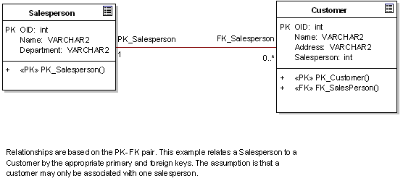
8. Map Aggregation and Composition
Aggregation and composition relationships are similar to the association relationship and map to tables related by primary-foreign key pairs. There are however, some points to bear in mind. Ordinary aggregation (the weak form) models relationships such as a Person resides at one or more Addresses. In this instance, more than one person could live at the same address, and if the Person ceased to exist, the Addresses associated with them would still exist. This example parallels the many-to-many relationship in relational terminology, and is usually implemented as a separate table containing a mapping of primary keys from one table to the primary keys of another.
A second example of the weak form of aggregation is where an entity has use or exclusive ownership of another. For example, a Person entity aggregates a set of shares. This implies a Person may be associated with zero or more shares from a Share table, but each Share may be associated with zero or one Person. If the Person ceases to exist, the Shares become un-owned or are passed to another Person. In the relational world, this could be implemented as each Share having an 'owner' column which stored a Person ID (or OID) .
The strong form of aggregation, however, has important integrity constraints associated with it. Composition, implies that an entity is composed of parts, and those parts have a dependent relationship to the whole. For example, a Person may have identifying documents such as a Passport, Birth Certificate, Driver's License & etc. A Person entity may be composed of the set of such identifying documents. If the Person is deleted from the system, then the identifying documents must be deleted also, as they are mapped to a unique individual.
If we ignore the OID issue for the moment, a weak aggregation could be implemented using either an intermediate table (for the many-to-many case) or with a foreign key in the aggregated class/table (one-to-many case). In the case of the many-to-many relationship, if the parent is deleted, the entries in the intermediate table for that entity must also be deleted also. In the case of the one-to-many relationship, if the parent is deleted, the foreign key entry (ie. 'owner') must be cleared.
In the case of composition, the use of a foreign key is mandatory, with the added constraint that on deletion of the parent the part must be deleted also. Logically there is also the implication with composition that the primary key of the part forms part of the primary key of the whole - for example, a Person's primary key may composed of their identifying documents ID's. In practice this would be cumbersome, but the logical relationship holds true.

9. Define relationship roles
For each association type relationship, each end of the relationship may be further specified with role information. Typically, you will include the Primary Key constraint name and the Foreign Key Constraint name. Figure 6 illustrates this concept. This logically defines the relationship between the two classes. In addition, you may specify additional constraints (eg. {Not NULL}) on the role and cardinality constraints (eg. 0..n).
10. Model behavior
We now come to another difficult issue: whether to map some or all class behavior to the functional capabilities provided by database vendors in the form of triggers, stored procedures, uniqueness and data constraints, and relational integrity. A non-persistent object model would typically implement all the behavior required in one or more programming languages (eg. Java or C++). Each class will be given its required behavior and responsibilities in the form of public, protected and private methods.
Relational databases from different vendors typically include some form of programmable SQL based scripting language to implement data manipulation. The two common examples are triggers and stored procedures. When we mix the object and relational models, the decision is usually whether to implement all the business logic in the class model, or to move some to the often more efficient triggers and stored procedures implemented in the relational DBMS. From a purely object-oriented point of view, the answer is obviously to avoid triggers and stored procedures and place all behavior in the classes. This localizes behavior, provides for a cleaner design, simplifies maintenance and provides good portability between DBMS vendors.
In the real world, the bottom line may be scaling to 100's or 1000's of transactions per second, something stored procedures and triggers are purpose designed for. If purity of design, portability, maintenance and flexibility are the main drivers, localize all behavior in the object methods.
If performance is an over-riding concern, consider delegating some behavior to the more efficient DBMS scripting languages. Be aware though that the extra time taken to integrate the object model with the stored procedures in a safe way, including issues with remote effects and debugging, may cost more in development time than simply deploying to more capable hardware.

As mentioned earlier, the UML Data Profile provides the following extensions (stereotyped operations) with which you can model DBMS behavior:
- Primary key constraint (PK);
- Foreign key constraint (FK);
- Index constraint (Index);
- Trigger (Trigger);
- Uniqueness constraint (Unique);
- Validity check (Check).
11. Produce a physical model
In UML, the physical model describes how something will be deployed into the real world - the hardware platform, network connectivity, software, operating system, dll's and other components. You produce a physical model to complete the cycle - from an initial use case or domain model, through the class model and data models and finally the deployment model. Typically for this model you will create one or more nodes that will host the database(s) and place DBMS software components on them. If the database is split over more than one DBMS instance, you can assign packages («schema») of tables to a single DBMS component to indicate where the data will reside.
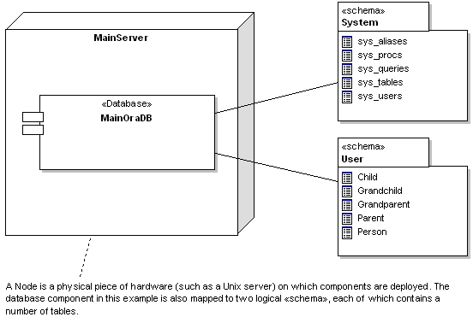

Conclusion
This concludes this short article on database modeling using the UML. As you can see, there are quite a few issues to consider when mapping from the object world to the relational. The UML provides support for bridging the gap between both domains, and together with extensions such as the UML Data Profile is a good language for successfully integrating both worlds.

